Project Design Phase Problem – Solution Fit Template

|  |  |
| --- | --- |
| Date | 26 June 2025 |
| Team ID | LTVIP2025TMID34546 |
| Project Name | Pattern sense:Classifying Fabric Patterns using Deep Learning |
| Maximum Marks | 2 Marks |

# Problem – Solution Fit Template:

In the textile industry, accurately identifying and classifying fabric patterns is a major challenge. Manual classification is time-consuming, error-prone, and inefficient—especially when dealing with a wide range of traditional and modern designs. Existing automated solutions often lack precision and do not generalize well across fabric types.

# Who faces the problem?

* Fabric designers
* Quality control teams
* Textile manufacturers and production supervisors

# Current scenario (without your solution):

* Reliance on human inspection, which is subjective and inconsistent
* Limited use of automation or outdated models with poor accuracy
* Lack of confidence scores or transparent classification
* Difficulty in processing large volumes of fabric samples quickly

# Purpose:

☑ Solve complex fabric classification problems in a way that fits the needs of textile industry professionals.

☑ Succeed faster by tapping into deep learning’s ability to handle large pattern datasets and variations.

☑ Sharpen your model’s accuracy and improve usability with clear labels and confidence scores.

☑ Increase efficiency in production and quality checks by automating repetitive pattern recognition tasks.

☑ Understand the existing classification challenges in order to build a reliable, scalable solution

# Template:

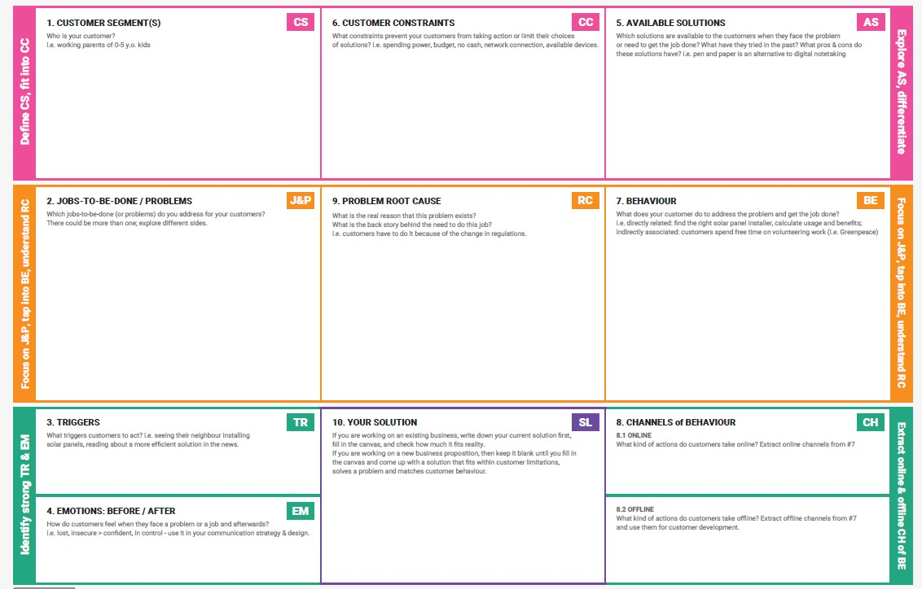

References:

1. <https://www.ideahackers.network/problem-solution-fit-canvas/>
2. [https://medium.com/@epicantus/problem-solution-fit-canvas-aa3dd59cb4fe](https://medium.com/%40epicantus/problem-solution-fit-canvas-aa3dd59cb4fe)